A2 Physics

Unit 5
Nuclear and Thermal Physics
1 Rutherford Scattering
2 Ionising Radiation
3 Radioactive Decay
4 Modes of Decay
5 Nuclear Radius
6 Mass and Energy
7 Fission and Fusion
8 Nuclear Reactors
9 Nuclear Safety As
10 Heat, Temperature and Internal Energy
11 The Specifics
12 Gas Laws
13 Ideal Gas
14 Molecular Kinetic Theory Model

Unit 5 | Rutherford Scattering
Lesson 1
Learning Outcomes | To know the set up of Rutherford’s experiment and the results he found
Learning Outcomes | To be able to explain how the results are evidence for the nucleus
Learning Outcomes | To know the factors we must consider when choosing the particle we will scatter | N. DWYER

Rutherford’s Scattering Experiment (Also seen in GCSE Physics 2)
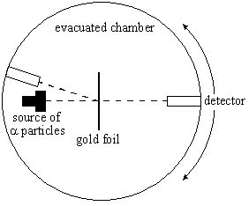
Hans Geiger and Ernest Marsden worked with Ernest Rutherford in his Manchester laboratories in 1909. They fired alpha particles (which they knew to have a positive charge) of a few MeV into a thin piece of gold foil. This was done in an evacuated chamber connected to a vacuum pump.
When the alpha particles passed through the gold foil they hit a zinc sulphide screen which emits light whenever an alpha particle strikes it. This screen was observed using a moving microscope in a dark room.
At the time the accepted structure of the atom was like a plum pudding: positive dough spread evenly with negative electrons scattered through out it like plums in a pudding.

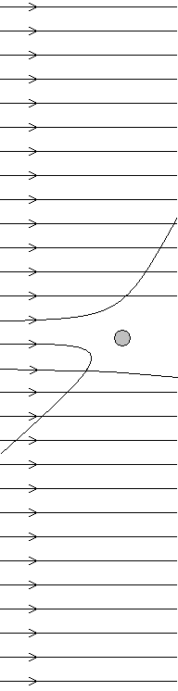
Results (Also seen in GCSE Physics 2)
Geiger and Marsden found that almost all of the alpha particles passed through with little or no deflection. Rutherford suggested moving the microscope in front of the foil, when they did they found that about 1 in every 8000 was ‘reflected’ back or scattered through an angle of more that 90°.
If the plum pudding model was the structure of the atom this would be like firing a bullet at a piece of toilet paper and it bouncing back – mental!

The Nuclear Model (Also seen in GCSE Physics 2)
Rutherford used these results to make the following conclusions:
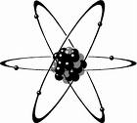Most of the mass must be gathered in one small volume – the nucleus.
They can repel a fast moving alpha particle
The nucleus must be positively charged.
They repel positive alpha particles
Most of the atom is empty space.
Only 1 in 8000 alpha particles are deflected
Negative electrons orbit the nucleus at a large distance from it.
Negative charges are needed to keep the atom neutral

Which Particle to Use?
There are two things to consider when using scattering to find the structure of things: the particle and the energy
Alpha Scattering: Rutherford used alpha particles with energies around 4MeV, any higher and it would be close enough to the nucleus to experience the strong nuclear force.
Electron Scattering: Electrons are accelerated to high energies of around 6GeV. They have enough energy to be scattered within protons and neutrons; discovering quarks. Electrons travelling at this speed have a de Broglie wavelength 1000 times smaller than visible light meaning we can see more detail.
X-ray Scattering: X-ray photons have short wavelengths and can be scattered or completely absorbed by atomic electrons. If the electron is tightly bound or the photon has very little energy the electron remains in the atom and the photon loses no energy. This is known as elastic or coherent scattering. If the photon has enough energy it knocks the electron out of orbit (ionisation) and does lose energy.
Neutron Scattering: Very useful because they are not charged but this limits the energies they can be accelerated to. Neutrons interact weakly with other nuclei and do not interact with electrons at all, because of this they can penetrate further. Their wavelengths are similar to that of atomic spacing, meaning that diffraction will occur.
Unit 5 | Ionising Radiation
Lesson 2
Learning Outcomes | To know what alpha, beta and gamma are and be able to list their uses and dangers
Learning Outcomes | To know the inverse-square law of radiation and be able to calculate intensity at given distances
Learning Outcomes | To know what background radiation is and what contributes to it | N. DWYER

Ionisation (Also seen in GCSE Physics 2)
The process of ionisation involves the removal of one or more electron from an atom. When radiation enters a GM tube it may ionise the atoms inside, the electrons are attracted to a positive wire and a small current flows. There are three types of radiation, each with its own properties, uses and dangers.

Alpha: A Helium nucleus – two protons and two neutrons
Relative mass: 4 Relative charge: +2 Deflection by E/M field: Yes
Ionising power: High Penetrating power: Low Range in air: 5cm Stopped by: Skin, paper
Uses: Smoke detectors, radiotherapy to treat cancer
Danger out of body: Low Danger in body: Cell death, mutation and cancer

Beta: A fast moving electron
Relative mass: 1/2000 Relative charge: -1 Deflection by E/M field: Yes
Ionising power: Medium Penetrating power: Medium Range in air: 2-3m Stopped by: Aluminium
Uses: Thickness control in paper production
Danger out of body: Damage to skin Danger in body: Similar to alpha but less damage

Gamma: A high frequency electromagnetic wave
Relative mass: 0 Relative charge: 0 Deflection by E/M field: No
Ionising power: Low Penetrating power: High Range in air: 15m Slowed by: Lead, concrete
Uses: Tracers: medical and industrial, sterilising surgical equipment
Danger out of body: Cell death, mutation and cancer Danger in body: Low

The Inverse-Square Law
Gamma radiation from a source will spread out. The radiation from a small source can be considered the same in all directions (isotropic), imagine a sphere around the source. As we move further away from the source the bigger the sphere gets. The same amount of energy is shared over a greater surface area. The further we move from the source the less intensity of the gamma radiation.
Intensity is measured in Watts, W
$I=\frac{{\text{kI}}_{0}}{x^{2}}$The intensity, I, of the radiation at a distance x from the source is given as
Where I₀ is the intensity at the source and k is a constant.

We do not always need to know the intensity at the source to find it at a given distance.
Consider two points, A and B, a certain distance away from a gamma source.
$I_{A}=\frac{{\text{kI}}_{0}}{(x_{A})^{2}}$ → $I_{A}(x_{A})^{2}={\text{kI}}_{0}$ and $I_{B}=\frac{{\text{kI}}_{0}}{(x_{B})^{2}}$ → $I_{B}(x_{B})^{2}={\text{kI}}_{0}$
We can combine these to give $I_{A}(x_{A})^{2}={\text{kI}}_{0}=I_{B}(x_{B})^{2}$ → $I_{A}(x_{A})^{2}=I_{B}(x_{B})^{2}$

Background Radiation (Also seen in GCSE Physics 2)
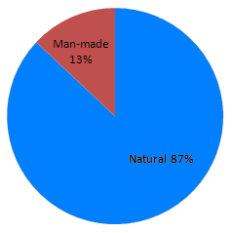
We are continuously exposed to a certain level of background radiation. In the lessons to come you must remember to subtract the background radiation from the recorded radiation level to get the true (or corrected) reading. The main contributors to background radiation are:

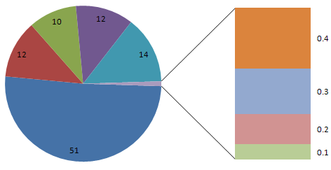
Radon and Thoron gas: 51%
Ground, rocks and buildings: 14%
Food and drink: 12%
Medical: 12%
Cosmic rays: 10%
Air travel: 0.4%
Nuclear weapons testing: 0.3%
Occupational: 0.2%
Nuclear power: 0.1%
Unit 5 | Radioactive Decay
Lesson 3
Learning Outcomes | To know what activity is and how to calculate it
Learning Outcomes | To know what the decay constant is and how to calculate it
Learning Outcomes | To know what half life is and be able to find it by calculation or graphical methods | N. DWYER

Decay (Also seen in GCSE Physics 1)
Something that is radioactive will decay into something that is stable. Radioactive decay happens randomly and spontaneously: there is no way of predicting when a radioactive nucleus will decay and external factors do not influence it at all (e.g. pressure and temperature).
What we can do is give a probability that a nucleus will decay in a given time.

Decay Constant, λ
Every radioactive isotope has its own probability that a nucleus will decay, called the decay constant.

Activity, A
The activity of a radioactive source is the number of decays that happen every second.
1 becquerel is equal to one decay per second, 50 becquerels is equal to 50 decay per second,
Activity is measured in becquerels, Bq (decays per second, s⁻¹)
During a certain amount of time, Δt, some radioactive atoms (ΔN) decay from a sample of N atoms.
The change in the number of nuclei in a certain time is$\frac{−ΔN}{Δt}=λN$ this can be written as $A=−λN$
The minus sign is there because we are losing nuclei, the number we have left is getting smaller.

Exponential Decay
$N=N_{0}e^{−λt}$As time passes the number of nuclei that decay every second will decrease.
To calculate the number of nuclei that we have left after a time, t, is given by:
$A=A_{0}e^{−λt}$Where N₀ is the number of nuclei at the start and N is the current number of nuclei. This is similar to the exponential decay equation of a discharging capacitor.
The equation for calculating the activity looks similar:

Half-Life (Also seen in GCSE Physics 1)
Each radioactive isotopes has its own half-life. We already know that it is:
The time it takes for the number of atoms in a sample to drop to half of its original sample or
The time it takes for the activity of a substance to drop to half of its original activity
Half-Life is measured in seconds, s
The half life of a substance is linked to the decay constant.
If there is a high probability that a nucleus will decay (λ = BIG) then it will not take long before half the sample has decayed to stability (half-life = short).
If there is a low probability that a nucleus will decay (λ = small) then it will take a long time for half of the sample to have decayed (half-life = LONG).
$T_{12}=\frac{\text{ln}2}{λ}$ where $T_{12}$is the half life

Graphs (Also seen in GCSE Physics 1)
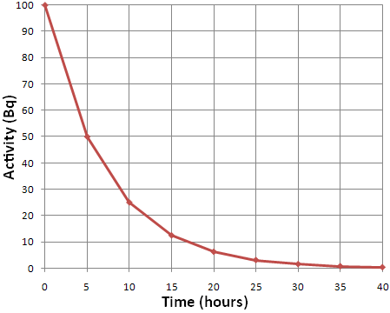
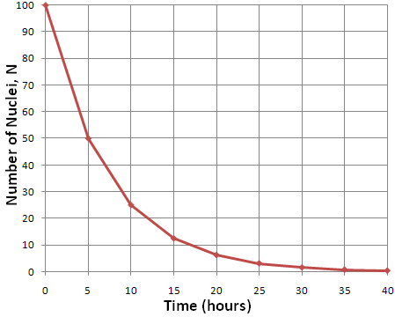
We can calculate the half-life from activity and number of nuclei graphs. Choose a starting value and then find how long it takes to fall to half this value. In the graphs we can see that both fall from 50 to 25 and take 5 hours to do this. Therefore the half-life is 5 hours. Knowing this we can then calculate the decay constant.
Unit 5 | Modes of Decay
Lesson 4
Learning Outcomes | To be able to sketch and label a graph of N against Z for stable and unstable nuclei
Learning Outcomes | To be able to state the changes to the parent nuclei when it undergoes: α decay, β⁻ decay, β⁺ decay,
Learning Outcomes | nucleon emission, electron capture and gamma ray emission | N. DWYER
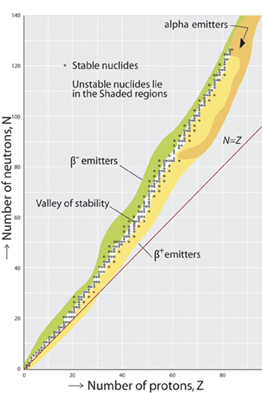

N Against Z Graph
Here is a graph of the number of neutrons against the number of protons in a nucleus. It shows stable and unstable nuclei.
Stable nuclei/isotopes are found on the black line/dots.
The shaded areas above and below the line of stability represent radioactive isotopes.
Why doesn’t it follow N=Z?
Protons repel each other with the electromagnetic force but the strong nuclear force is stronger at small distances and keeps them together in the nucleus. We can see the line of stability follows N=Z at low values.
As the nucleus gets bigger there are more protons, when they become a certain distance apart they no longer experience the strong nuclear force that keeps them together, only the electromagnetic which pushes them apart. To keep the nucleus together we need more neutrons which feel no electromagnetic repulsion only the attraction of the strong nuclear force.
Points to remember
Follows N=Z around Z=20, then curves to go through Z=80 N=120
β⁻ emitters above the line, β⁺ emitters below the line and α at the top

Alpha Decay (Also seen in GCSE Physics 2)
An alpha particle (a Helium nucleus) is ejected from the parent nucleus.
${}_{Z}^{A}{}X→{}_{Z−2}^{A−4}{}Y+{}_{2}^{4}{}α$ Loss: 2 protons, 2 neutrons

Beta Minus Decay (Also seen in GCSE Physics 2)
A neutron is transformed into a proton (that stays in the nucleus) and an electron (which is emitted).
${}_{Z}^{A}{}X→{}_{Z+1}^{A}{}Y+{}_{−1}^{0}{}e+{\overline{ν}}_{e}$ Loss: 1 neutron Gain: 1 proton

Beta Plus Decay
A proton is transformed into a neutron and a positron.
${}_{Z}^{A}{}X→{}_{Z−1}^{A}{}Y+{}_{+1}^{0}{}e+ν_{e}$ Loss: 1 proton Gain: 1 neutron

Electron Capture
A nucleus can capture one of the orbiting electrons. A proton changes into a neutron.
${}_{Z}^{A}{}X+{}_{−1}^{0}{}e→{}_{Z−1}^{A}{}Y+ν_{e}$ Loss: 1 proton Gain: 1 neutron

Nucleon Emission Decay
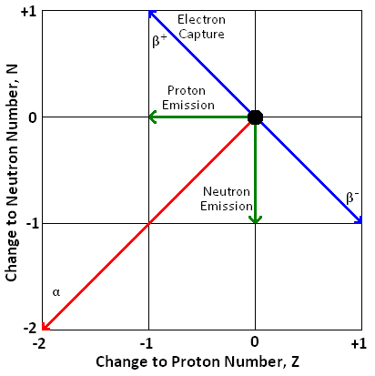
It is possible for an unstable isotope to emit a nucleon from the nucleus.
In proton-rich or proton-heavy nuclei it is possible (though rare) for a proton to be emitted.
${}_{Z}^{A}{}X→{}_{Z−1}^{A−1}{}Y+{}_{1}^{1}{}p$ Loss: 1 proton
In neutron-rich or neutron-heavy nuclei it is possible (though rare) for a neutron to be emitted.
${}_{Z}^{A}{}X→{}_{Z}^{A−1}{}X+{}_{0}^{1}{}n$ Loss: 1 neutron

Gamma Ray Emission (Also seen in GCSE Physics 2)
Alpha emission is often followed by gamma ray emission. The daughter nuclei are left in an excited state (remember energy levels from Unit 1) which they will at some point fall from to the ground state, emitting a gamma photon. There is no nuclear structure change, just a change of energy.
${}_{Z}^{A}{}X→{}_{Z}^{A}{}X+γ$ Loss: Energy
Unit 5 | Nuclear Radius
Lesson 5
Learning Outcomes | To be able to calculate the radius of a nucleus by the closest approach of alpha particles
Learning Outcomes | To be able to calculate the radius of a nucleus by the diffraction angle of electrons
Learning Outcomes | To be able to calculate the nuclear radius and nuclear density | N. DWYER

Rutherford gave us an idea of the size of the nucleus compared to the atom but more experimental work has been done to find a more accurate measurement.

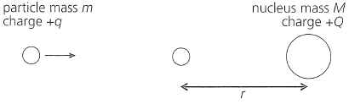
Closest Approach of Alpha Particles
Rutherford fired alpha particles at gold atoms in a piece of foil. They approach the nucleus but slow down as the electromagnetic repulsive force become stronger. Eventually they stop moving, all the kinetic energy has been converted into potential energy as the particles come to rest at a distance r from the centre of the nucleus.
$E_{K}=E_{P}$ → $E_{P}=\text{qV}$ where V is the electric potential at a distance of r from the centre
$E_{P}=q\frac{Q}{4{\text{πε}}_{0}r}$ → $E_{K}=q\frac{Q}{4{\text{πε}}_{0}r}$ → $r=q\frac{Q}{4{\text{πε}}_{0}E_{K}}$
This gives us the upper limit of the radius of a nucleus.
Calculating the nuclear radius this way gives us a value of r = 4.55 x 10⁻¹⁴ m or 45.5 fm (where 1 fm = 1 x 10⁻¹⁵ m)
Modern measurements give us values of approximately r = 6.5 fm
(Remember that 1 eV of energy is equal to 1.6 x 10⁻¹⁹ J)

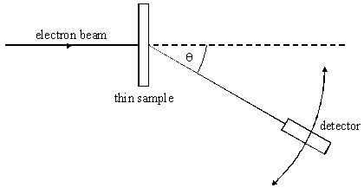
Electron Diffraction
A beam of electrons were fired at a thin sample of atoms and the diffraction pattern was detected and then examined.
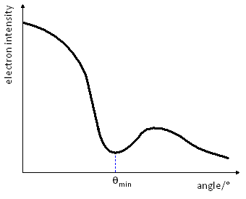
The graph shows a minimum at a value of θ_{min}. We can use this to find a value of the nuclear radius.
$\text{sin}θ_{\text{min}}=\frac{0\text{.}\text{61}λ}{D}$
Where D is the nuclear radius and λ is the de Broglie wavelength of the beam of electrons. We can calculate this as follows:

The kinetic energy gained by the electrons is $E_{K}=\text{eV}$ where e is the charge on the electron and V is the potential difference used to accelerate it. So we now have:
$\frac{1}{2}{\text{mv}}^{2}=\text{eV}$ → ${\text{mv}}^{2}=2\text{eV}$ → $m^{2}v^{2}=2\text{meV}$ → $\sqrt{m^{2}v^{2}}=\sqrt{2\text{meV}}$ → $\text{mv}=\sqrt{2\text{meV}}$
We can now substitute this into the equation for de Broglie wavelength: $λ=\frac{h}{\text{mv}}$ → $λ=\frac{h}{\sqrt{2\text{meV}}}$

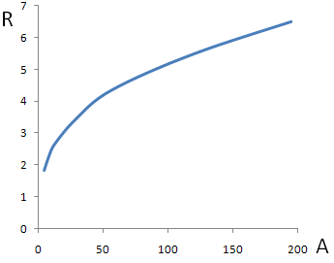
Nuclear Radius
From the experimental results a graph was plotted of R against A. A graph like the one to the right was obtained. They saw that R depends not on A, but on A^{⅓}.
When they plotted the graph of R against A^{⅓} they found a straight line that cut the origin and had a gradient of r₀. (r₀ is a constant representing the radius of a single nucleon and has a value of between 1.2 and 1.5 fm)
The radius of a nucleus has been found to be: $R=r_{0}A^{13}$

Nuclear Density
Now that we have an equation for the nuclear radius we can calculate the density of a nucleus.
If we have a nucleus of A nucleons, we can assume the mass is Au and the volume is the volume of a sphere:
$ρ=\frac{m}{V}$ → $ρ=\frac{\text{Au}}{\frac{4}{3}{πR}^{3}}$ → $ρ=\frac{\text{Au}}{\frac{4}{3}π(r_{0}A^{13})^{3}}$ → $ρ=\frac{\text{Au}}{\frac{4}{3}{πr}_{0^{3}}A}$ → $ρ=\frac{u}{\frac{4}{3}{πr}_{0^{3}}}$
We can see that the density is independent of the nucleon number and gives a value of: 3.4 x 10¹⁷ kg m⁻³.
Unit 5 | Mass and Energy
Lesson 6
Learning Outcomes | To be able to explain what mass defect is and be able to calculate
Learning Outcomes | To be able to explain what binding energy is and be able to calculate
Learning Outcomes | To be able to sketch the graph of B.E. per nucleon against nucleon number | N. DWYER

Disappearing Mass
The mass of a nucleus is less than the mass of the protons and neutrons that it is made of.
(mass of protons + mass of neutrons) – mass of nucleus = ∆m
∆m is the difference in the masses and is called the mass defect.
Let us look at the nucleus of a Helium atom to see this in action. It is made up of 2 protons and 2 neutrons:
Mass of nucleons = 2 x (mass of proton) + 2 x (mass of neutron)
Mass of nucleons = 2 x (1.673 x 10⁻²⁷) + 2 x (1.675 x 10⁻²⁷)
Mass of nucleons = 6.696 x 10⁻²⁷ kg Mass of nucleus = 6.648 x 10⁻²⁷ kg
Mass defect = mass of nucleons – mass of nucleus
Mass defect = 6.696 x 10⁻²⁷ – 6.648 x 10⁻²⁷ = 0.048 x 10⁻²⁷ kg

As we can see, we are dealing with tiny masses. For this reason we will use the atomic mass unit, u
Particle | Mass (kg) | Mass (u)
Proton | 1.673 x 10⁻²⁷ | 1.00728
Neutron | 1.675 x 10⁻²⁷ | 1.00867
Electron | 9.11 x 10⁻³¹ | 0.00055
1u = 1.661 x 10⁻²⁷ kg
The mass defect now becomes = 0.029 u

Einstein to the Rescue
In 1905, Einstein published his theory of special relativity. In this it is stated that:
$E={\text{mc}}^{2}$ Energy is equal to the mass multiplied by the speed of light squared.
This means gaining energy means a gain in mass, losing energy means losing mass. The reverse must be true.
Gaining mass means a gain in energy, losing mass means a loss in energy.
The energy we are losing is the binding energy.
$E=Δ{\text{mc}}^{2}$ where ∆m is the mass defect and E is binding energy

Binding Energy
As the protons and neutrons come together the strong nuclear force pulls them closer and they lose potential energy. (Like how an object loses its gravitational potential energy as it falls to the Earth.)
Energy must be done against the s.n.f. to separate the nucleus into the nucleons it is made of. This is called the binding energy (although ‘unbinding’ energy would be a better way to think of it).

The binding energy of the Helium nucleus from above would be: E = m c² → E = (0.048 x 10⁻²⁷) x (3.0 x 10⁸)²
E = 4.32 x 10⁻¹² J
The Joule is too big a unit to use at the atomic scale. We will use the electron Volt (see AS Unit 1)
1u = 1.5 x 10⁻¹⁰ J and 1eV = 1.60 x 10⁻¹⁹ J → 1u = 931.3 MeV
We can now calculate the binding energy of the Helium nucleus to be: E = 27 MeV (27 million eV)

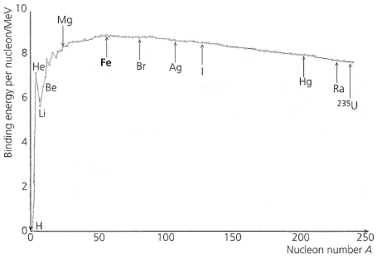
Binding Energy Graph
The binding energy is the energy required to separate a nucleus into its constituent nucleons. The binding energy per nucleon gives us the energy required to remove one proton or neutron from the nucleus.
The graph of binding energy per nucleon against nucleon number looks like this.
There is an increase in the energy required to remove one nucleon up until the peak of 8.8 MeV at Iron 56. The line then gently decreases. This means Iron is the most stable nucleus because it requires the largest amount of energy to remove one nucleon. This will also mean that there is the greatest mass defect.
Unit 5 | Fission and Fusion
Lesson 7
Learning Outcomes | To know what occurs in nuclear fission and nuclear fusion processes
Learning Outcomes | To know what a chain reaction is, how it occurs and what critical mass is
Learning Outcomes | To be able to state and explain whether fission or fusion will occur | N. DWYER

Nuclear Fission (Also see GCSE Physics 2)
Fission occurs when a nucleus splits into two smaller nuclei
We make fission happen by firing slow moving neutrons at Uranium 235, Plutonium 239 or Thorium 232 nuclei. We call this induced fission. In this processes the nucleus absorbs a neutron then splits to form two lighter nuclei, releases energy and any neutrons left over, usually 2 or 3.
Here is a possible equation for the fission of Uranium 235:
${}_{\text{92}}^{\text{235}}{}U+{}_{0}^{1}{}n→{}_{\text{56}}^{\text{144}}{}\text{Ba}+{}_{\text{36}}^{\text{90}}{}\text{Kr}+2{}_{0}^{1}{}n+\text{energyreleased},E$
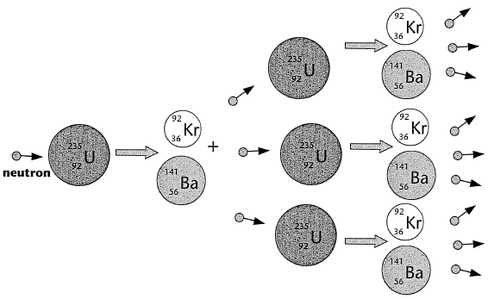

Chain Reaction
In the above reaction two free neutrons were released, these can also be absorbed by two heavy nuclei and cause a fission process. These nuclei would release more neutrons which could cause further fissions and so on.

Critical Mass
For a chain reaction to happen the mass of the fissionable material must be greater than a certain minimum value. This minimum value is known as the critical mass and is when the surface area to mass ratio is too small.
If mass < critical mass: more neutrons are escaping than are produced. Stops
If mass = critical mass: number of neutrons escaping = number of neutrons produced. Steady
If mass > critical mass: more neutrons are produced than are escaping. Meltdown

Nuclear Fusion (Also see GCSE Physics 2)
Fusion occurs when two nuclei join to form a bigger nucleus
The two nuclei must have very high energies to be moving fast enough to overcome the electrostatic repulsion of the protons then, when close enough, the strong nuclear force will pull the two nuclei together.
Here is an example of the fusing of two hydrogen isotopes:
${}_{1}^{2}{}H+{}_{1}^{3}{}H→{}_{2}^{4}{}\text{He}+{}_{0}^{1}{}n+\text{energyreleased},E$

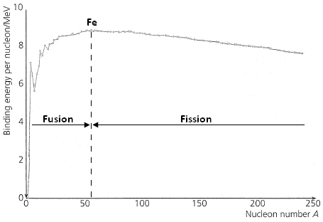
Which Will Happen?
Looking at the graph we can see the Iron 56 has the highest binding energy per nucleon, the most energy required to remove one proton or neutron from the nucleus. This makes it the most stable.

Nuclei lighter than Iron will undergo fusion.
Protons and neutrons feel the attraction of the strong nuclear force but only protons feel the repulsion of the electrostatic force. For light nuclei, adding an extra proton increases the strong nuclear force to pull the nucleon together. This is because at this range the s.n.f. force is stronger than the other three fundamental forces.
The nucleons move closer together → potential energy is lost → energy is given out

Nuclei heavier than Iron will undergo fission.
Beyond Iron, each proton that is added to the nuclei adds to the electrostatic repulsion. The bigger the nucleus become the less the outer protons feel the strong nuclear force from the other side. We can see the binding energy per nucleon decrease for heavier nuclei.
A big nucleus will break into two smaller nuclei, each being stronger bonded together due to the smaller size.
The nucleons move closer together → potential energy is lost → energy is given out.
Unit 5 | Nuclear Reactors
Lesson 8
Learning Outcomes | To be able to explain how a nuclear reactor produces electricity
Learning Outcomes | To be able to explain the roles of the fuel rods, moderator, coolant and control rods
Learning Outcomes | To be able to give examples of the materials use for each of the above | N. DWYER

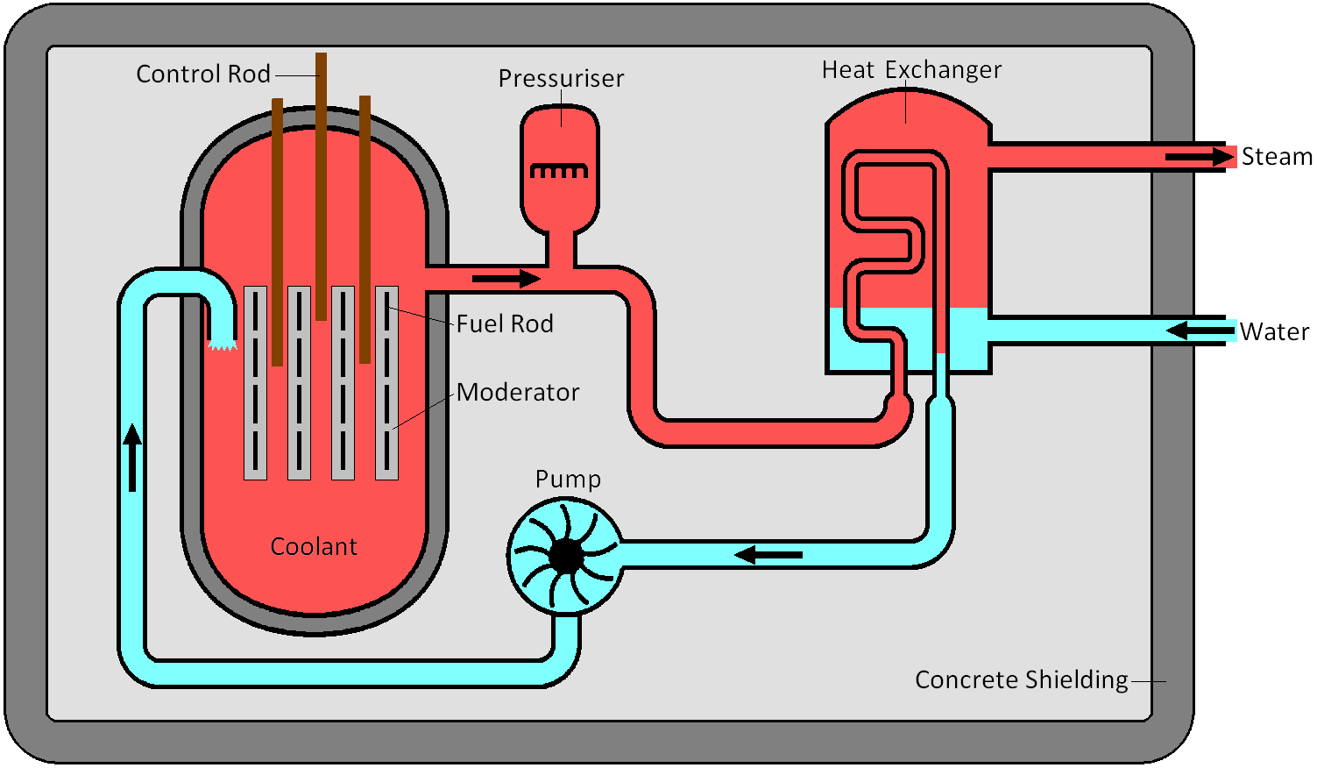
Making Electricity
This is a typical nuclear fission reactor.
A nuclear power station is similar to a power station powered by the combustion of fossil fuels or biomass. In such a station the fuel is burnt in a boiler, the heat this produces it uses to heat water into steam in the pipes that cover the roof and walls of the boiler. This steam is used to turn a turbine which is connected to a generator that produces electricity (see GCSE Physics 3 and A2 Unit 4). Steam enters the cooling towers where is it condensed into water to be used again.
In a nuclear fission reactor the heat is produced in a different way.

Components of a Nuclear Reactor
Fuel Rods
This is where nuclear fission reactions happen. They are made or Uranium and there are hundreds of them spread out in a grid like pattern.
Natural Uranium is a mixture of different isotope. The most common are U²³⁸ which accounts for 99.28% and U²³⁵ which accounts for only 0.72% of it. 238 will only undergo fission when exposed to very high-energy neutrons whilst 235 will undergo fission much more easily. The Uranium that is used in fuel rods has a higher percentage of 235 and is said to be enriched. This is so more fission reactions may take place.
Moderator
Role: The neutrons that are given out from nuclear fission are travelling too fast to cause another fission process. They are released at 1 x 10⁷ m/s and must be slowed to 2 x 10³ m/s, losing 99.99975% of their kinetic energy. The neutrons collide with the atoms of the moderator which turns the kinetic energy into heat.
Neutrons that are travelling slow enough to cause a fission process are called thermal neutrons, this is because they have the same amount of kinetic energy as the atoms of the moderator (about 0.025 eV at 20°C).
Factors affecting the choice of materials: Must have a low mass number to absorb more kinetic energy with each collision and a low tendency to absorb neutrons so it doesn’t hinder the chain reaction.
Typical materials: graphite and water.
Coolant
Role: Heat is carried from the moderator to the heat exchanger by the coolant. The pressuriser and the pump move the hot coolant to the heat exchanger, here hot coolant touches pipes carrying cold water. Heat flows from hot coolant to cold water turning the water into steam and cooling the coolant. The steam then leaves the reactor (and will turn a turbine) as the coolant return to the reactor.
Factors affecting the choice of materials: Must be able to carry large amounts of heat (L11 The Specifics), must be gas or liquid, non-corrosive, non-flammable and a poor neutron absorber (less likely to become radioactive).
Typical materials: carbon dioxide and water.
Control rods
Role: For the reactor to transfer energy at a constant rate each nuclear fission reaction must lead to one more fission reaction. Since each reaction gives out two or more we must remove some of the extra neutrons. The control rods absorb neutrons, reducing the amount of nuclear fission processes occurring and making the power output constant. They can be lowered further into the fuel rods to absorb more neutrons and further reduce the amount of fission occurring. Some neutrons leave the reactor without interacting, some travel too fast while other are absorbed by U²³⁸ nuclei. If we need more neutrons we can raise the control rods.
Factors affecting the choice of materials: Ability to absorb neutrons and a high melting point.
Typical materials: boron and cadmium.
Unit 5 | Nuclear Safety Aspects
Lesson 9
Learning Outcomes | To be able to list and explain the safety features of a nuclear reactor
Learning Outcomes | To be able to explain how an emergency shut-down happens in a nuclear reactor
Learning Outcomes | To be able to state and explain the methods of nuclear waste disposal | N. DWYER

Nuclear Reactor Safety
There are many safety features and controls in place designed to minimise the risk of harm to humans and the surrounding environment.
Fuel Used
Using solids rather than liquids avoids the danger of leaks or spillages. They are inserted and removed from the reactor by remote controlled handling devices.
Shielding
The reactor core (containing the fuel, moderator and control rods) is made from steel and designed to withstand high temperatures and pressures.
The core itself is inside a thick, leak proof concrete box which absorbs escaping neutrons and gamma radiation.
Around the concrete box is a safety area, not to be entered by humans.
Emergency Shut-down
There are several systems in place to make it impossible for a nuclear disaster to take place:
If the reactor needs stopping immediately the control rods are inserted fully into the core, they absorb any neutrons present and stop any further reactions from happening.
Some reactors have a secondary set of control rods held up by an electromagnet, so if a power cut happens the control rods fall into the core.
If there is a loss of coolant and the temperature of the core rises beyond the safe working limits an emergency cooling system floods the core (with nitrogen gas or water) to cool it and absorb any spare neutrons.

Nuclear Waste Disposal
There are three levels of waste, each is produced, handled and disposed of in different ways:
High-level Radioactive Waste
What it is? Spent fuel rods from the reactor and unwanted, highly radioactive material separated from the spent fuel rods.
How do we get rid? The spent fuel rods are taken from the reactor and stored in cooling ponds with in the power station to allow most of the short-term radioactivity to die away. It is then transported to a processing plant. Here it is encased in steel containers and kept under water.
The cladding is eventually removed and the fuel rods are separated into unused uranium and plutonium and highly radioactive waste.
The uranium and plutonium is kept in sealed container for possible future use.
The waste is converted into powder, fused into glass blocks, sealed in air-cooled containers for around 50 years before being stored deep underground in a stable rock formation.
Time scale? Up to a year in the cooling ponds. Radioactive waste can remain at dangerous levels for thousands of years.

Intermediate-level Radioactive Waste
What it is? Fuel element cladding, sludge from treatment processes, contaminated equipment, hospital radioisotopes and containers of radioactive materials.
How do we get rid? Sealed in steel drums that are encased in concrete and stored in buildings with reinforced concrete. Also stored deep underground in a suitable location that has a stable rock formation and low water flow.
Time scale? Thousands of years.

Low-level Radioactive Waste
What is it? Worn-out laboratory equipment, used protective clothing, wrapping material and cooling pond water.
How do we get rid? Sealed in metal drums and buried deep underground in a supervised repository. Treated cooling pond water is released into the environment.
Time scale? A few months.

Unit 5 | Heat, Temperature and Internal Energy
Lesson 10
Learning Outcomes | To know what internal energy is
Learning Outcomes | To be able to explain the difference between heat, temperature and internal energy
Learning Outcomes | To be able to explain what absolute zero is and how it was found | N. DWYER

Internal Energy
The internal energy of a substance is due to the vibrations/movement energy of the particles (kinetic) and the energy due to the bonds holding them together (potential).
Solids: In a solid the particles are arranged in a regular fixed structure, they cannot move from their position in the structure but can vibrate. The internal energy of a solid is due to the kinetic energy of the vibrating particles and the potential energy from the bonds between them.
Liquids: In a liquid the particles vibrate and are free to move around but are still in contact with each other. The forces between them are less than when in solid form. The internal energy of a liquid is due to the kinetic and potential energies of the particles but since they are free to slide past each other the potential energy is less than that of it in solid form.
Gases: In a gas particles are free to move in all directions with high speeds. There are almost no forces of attraction between them. The internal energy of a gas is almost entirely due to the kinetic energy of the particles.
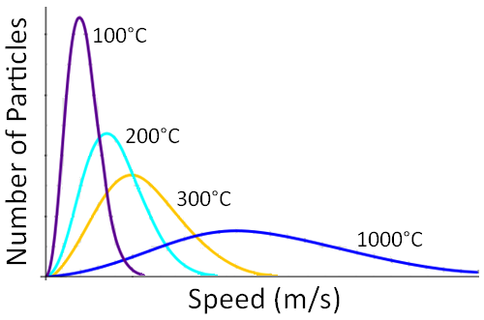

Temperature
Temperature is a measure of the kinetic energies of the particles in the substance. As we can see from the graph something with a high temperature means the particles are vibrating/moving with higher average speeds that a substance at a lower temperature.
It is possible for two objects/substances to be at the same temperature but have different internal energies. We will go into this further in the next lesson: The Specifics.

Heat
Heat is the flow of thermal energy and it flows from a high temperature to a low temperature.
If two objects are at the same temperature we say that they are in thermal equilibrium and no heat flows.
If object A is in thermal equilibrium with object B and object B is in thermal equilibrium with object C then A and C must be in thermal equilibrium with each other.
Get into a hot or cold bath and energy is transferred:
In a cold bath thermal energy is transferred from your body to the water.
In a hot bath thermal energy is transferred from the water to your body.
As the energy is transferred you and the water become the same temperature. When this happens there is no longer a flow of energy → so no more heat. You both still have a temperature due to the vibrations of your particles but there is no longer a temperature difference so there is no longer a flow of energy.

Temperature Scale
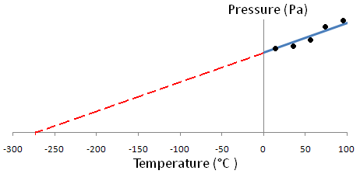
The Celsius scale was established by giving the temperature at which water becomes ice a value of 0 and the temperature at which it boils a value of 100. Using these fixed points a scale was created.

Absolute Zero and Kelvins
In 1848 William Thomson came up with the Kelvin scale for temperature. He measured the pressure caused by gases at known temperatures (in °C) and plotted the results. He found a graph like this one.
By extrapolating his results he found the temperature at which a gas would exert zero pressure. Since pressure is caused by the collisions of the gas particles with the container, zero pressure means the particles are not moving and have a minimum internal energy. At this point the particle stops moving completely and we call this temperature absolute zero, it is not possible to get any colder. This temperature is -273°C.
1 Kelvin is the same size as 1 degree Celsius but the Kelvin scale starts at absolute zero.
°C = K – 273 K = °C + 273
Unit 5 | The Specifics
Lesson 11
Learning Outcomes | To be able to explain and calculate specific heat capacity
Learning Outcomes | To be able to explain and calculate specific latent heat
Learning Outcomes | To know the correct units to use and the assumptions we make in energy transfer | N. DWYER

Specific Heat Capacity
We know that when we heat a substance the temperature will increase. The equation that links heat (energy) and temperature is:
$$ΔQ=\text{mc}ΔT$$
c is the specific heat capacity which is the energy required to raise the temperature of 1 kg of a substance by 1 degree. It can be thought of as the heat energy 1 kg of the substance can hold before the temperature will increase by 1 degree.
Specific Heat Capacity is measured in Joules per kilogram per Kelvin, J/kg K or J kg⁻¹ K⁻¹

Water Analogy
We can think of the energy being transferred as volume of water. Consider two substances: one with a high heat capacity represented by 250 ml beakers and one with a low heat capacity represented by 100 ml beakers. When a beaker is full the temperature of the substance will increase by 1 degree.
We can see that 2 litres of water will fill 8 of the 250 ml beakers or 20 of the 100ml beakers meaning the same amount of energy can raise the temperature of the first substance by 8 degrees or the second by 20 degrees.

Changes of State
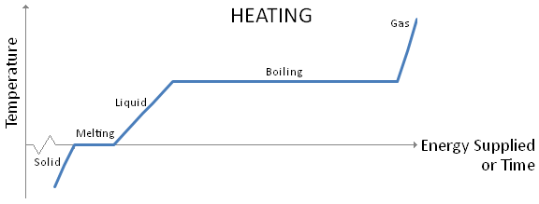
When a substance changes state there is no change in temperature.

When a solid is heated energy is transferred to the particles making them vibrate more which means the temperature increases. The potential energy of the solid remains constant but the kinetic energy increases.
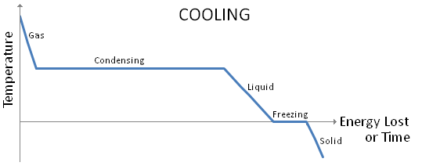
At melting point the particles do not vibrate any faster, meaning the kinetic energy and temperature are constant. The bonds that keep the particles in a rigid shape are broken and the potential energy increases.
In liquid form the particles are still in contact with each other but can slide past each other. As more energy is transferred the particles vibrate more. The kinetic energy increases but the potential energy is constant.
At boiling point the particles do not vibrate any faster, meaning the kinetic energy and temperature are constant. The bonds holding the particles together are all broken, this takes much more energy than when melting since all the bonds need to be broken.
When a gas is heated the particles move faster, meaning the kinetic energy and temperature increases. The potential energy stays constant.

Specific Latent Heat
Different substances require different amounts of energy to change them from solid to liquid and from liquid to gas. The energy required is given by the equation:
$$Q=\text{ml}$$
l represents the specific latent heat which is the energy required to change 1 kg of a substance from solid to liquid or liquid to gas without a change in temperature.
Specific Latent Heat is measured in Joules per kilogram, J/kg or J kg⁻¹
The specific latent heat of fusion is the energy required to change 1 kg of solid into liquid
The specific latent heat of vaporisation is the energy required to change 1 kg of liquid into gas.
As we have just discussed, changing from a liquid to a gas takes more energy than changing a solid into a gas, so the specific latent heat of vaporisation is higher than the specific latent heat of fusion.
Unit 5 | Gas Laws
Lesson 12
Learning Outcomes | To know and be able to use the correct units for volume, temperature and pressure
Learning Outcomes | To be able to state Boyle’s Charles’ and the Pressure law for gases
Learning Outcomes | To be able to sketch the graphs that show these laws | N. DWYER

Gas Properties
Volume, V: This is the space occupied by the particles that make up the gas.
Volume is measured in metres cubed, m³
Temperature, T: This is a measure of the internal energy of the gas and this is equal to the average kinetic energy of its particles.
Temperature is measured in Kelvin, K
Pressure, p: When a gas particle collides with the walls of its container it causes a pressure. Pressure is given by the equation pressure = Force/Area or ‘force per unit area’.
Pressure is measured in pascals, Pa
1 pascal is equal to a pressure of 1 newton per square metre.

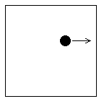
Understanding the Gas Laws
We are about to look at the three different laws that all gases obey. To help us understand them let us apply each one to a simple model. Image one ball in a box; the pressure is a measure of how many collisions between the ball and the box happen in a certain time, the volume is the area of the box and the temperature is the average speed of the ball. To simply thing further let us assume it is only moving back and forth in the x direction.

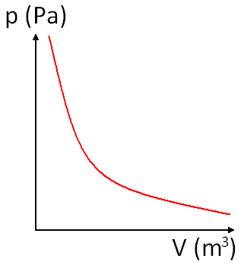
Boyle’s Law
The pressure of a fixed mass of gas is inversely proportional to its volume when kept at a constant temperature.
$p∝\frac{1}{V}$ for constant T
Think about it…
If temperature is constant this means that the ball is travelling at a fixed, constant speed. If we increase the size of the box it makes fewer collisions in the same time because it has to travel further before it collides with the side. If we make the box smaller the ball will collide with the box more often since it has less distance to travel.
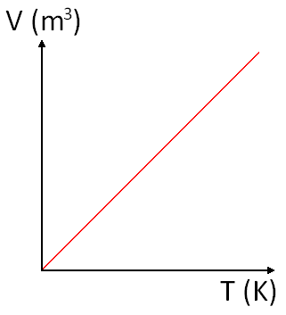

Charles’ Law
All gases expand at the same rate when heated. The volume of a fixed mass of gas is proportional to its temperature when kept at a constant pressure.

$V∝T$ for constant p
Think about it…
If pressure is constant that means that the same number of collisions with the box are taking place. So if the box was made bigger the ball would have to move faster to make sure there were the same amount of collisions per unit time.
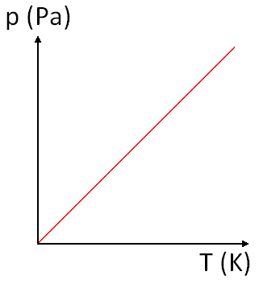

The Pressure Law
The pressure of a fixed mass of gas is proportional to its temperature when kept at a constant volume.

$p∝T$ for constant V
Think about it…
If the volume in constant it means the box has a fixed size. If we increase the speed at which the ball is moving it will hit the sides of the box more often. If we slow the ball down it will hit the sides less often.

Unit 5 | Ideal Gases
Lesson 13
Learning Outcomes | To be able to calculate the pressure, volume or temperature of a gas
Learning Outcomes | To know and be able to use the ideal gas equation
Learning Outcomes | To know the significance of Avogadro’s constant, Boltzmann’s constant and moles | N. DWYER

Messing with Gases
The three gas laws can be combined to give us the equation: $\text{pV}∝T$
We can rearrange this to give: $\frac{\text{pV}}{T}=$constant
We can use this to derive a very useful equation to compare the pressure, volume and temperature of a gas that is changed from one state (p₁, V₁, T₁) to another (p₂, V₂, T₂). $\frac{p_{1}V_{1}}{T_{1}}=\frac{p_{2}V_{2}}{T_{2}}$
Temperatures must be in Kelvin, K

Avogadro and the Mole
One mole of a material has a mass of M grams, where M is the molecular mass in atomic mass units, u. Oxygen has a molecular mass of 16, so 1 mole of Oxygen atoms has a mass of 16g, 2 moles has a mass of 32g and so on. An Oxygen molecule is made of two atoms so it has a molecular mass of 32g. This means 16g would be half a mole of Oxygen molecules.
$n=\frac{m}{M}$ where n is the number of moles, m is the mass and M is the molecular mass.

Avogadro suggested that one mole of any substance contains the same number of particles, he found this to be 6.02 x 10²³. This gives us a second way of calculating the number of moles
$n=\frac{N}{N_{A}}$ where N is the number of particles and N_{A} is the Avogadro constant.
N_{A} is the Avogadro Constant, N_{A} = 6.02 x 10²³ mol⁻¹

Ideal Gases
We know from the three gas laws that $\frac{\text{pV}}{T}=$constant
Ideal gases all behave in the same way so we can assign a letter to the constant. The equation becomes:
$\frac{\text{pV}}{T}=R$
If the volume and temperature of a gas are kept constant then the pressure depends on R and the number of particles in the container. We must take account of this by bringing the number of moles, n, into the equation:
$\frac{\text{pV}}{T}=\text{nR}$ → $\text{pV}=\text{nRT}$
R is the Molar Gas Constant, R = 8.31 J K⁻¹ mol⁻¹
This is called the equation of state for an ideal gas. The concept of ideal gases is used to approximate the behaviour of real gases. Real gases can become liquids at low temperatures and high pressures.

Using the Avogadro’s equation for n we can derive a new equation for an ideal gas:
$\text{pV}=\text{nRT}$ → $\text{pV}=\frac{N}{N_{A}}\text{RT}$ → $\text{pV}=N\frac{R}{N_{A}}T$

Boltzmann Constant – cheeky!
Boltzmann noticed that R and N_{A} in the above equation are constants, so dividing one by the other will always give the same answer. The Boltzmann constant is represented by k and is given as
$$\frac{R}{N_{A}}=k$$
k is the Boltzmann Constant, k = 1.38 x 10⁻²³ J K⁻¹
$\text{pV}=\text{nRT}$ can become $\text{pV}=N\frac{R}{N_{A}}T$which can also be written as $\text{pV}=\text{NkT}$
Unit 5 | Molecular Kinetic Theory Model
Lesson 14
Learning Outcomes | To be able to list the assumptions needed to derive an equation for the pressure of a gas
Learning Outcomes | To be able to derive an equation for the pressure of a gas
Learning Outcomes | To be able to calculate the mean kinetic energy of a gas molecule | N. DWYER

Assumptions
- There are a very large number of molecules (N)
- Molecules have negligible volume compared to the container
- The molecules show random motion (ranges of speeds and directions)
- Newton’s Laws of Motion can be applied to the molecules
- Collisions are elastic and happen quickly compared to the time between collisions
- There are no intermolecular forces acting other than when they collide

The Big, Bad Derivation
The molecules move in all directions. Let us start with one molecule of mass m travelling with velocity v_{x}. It collides with the walls of the container, each wall has a length of L.
Calculate the change in momentum: before it moves with velocity v_{x} and after the collision it move with –v_{x} . $Δ\text{mv}=({\text{mv}}_{x})−(−{\text{mv}}_{x})$ → $Δ\text{mv}=2{\text{mv}}_{x}$ Equation 1
$F=\frac{2{\text{mv}}_{x}}{\left(\frac{2L}{v_{x}}\right)}$$F=2{\text{mv}}_{x}\text{.}\left(\frac{v_{x}}{2L}\right)$The time can be given by using distance/speed: the speed is v_{x} and the distance is twice the length of the box (the distance to collide and then collide again with the same wall) $t=\frac{2L}{v_{x}}$ Equation 2
Force can be calculated by: $F=\frac{Δ\text{mv}}{Δt}$ Substitute in Equation 1 and 2 → →
$F=\frac{{\text{mv}}_{x^{2}}}{L}$
- Equation 3, gives the force of one molecule acting on the side of the container.

We can now calculate the pressure this one molecule causes in the x direction:
$p=\frac{F}{A}$ Substituting Equation 3 → $p=\frac{{\text{mv}}_{x^{2}}L}{L^{2}}$ → $p=\frac{{\text{mv}}_{x^{2}}}{L^{3}}$ → $p=\frac{{\text{mv}}_{x^{2}}}{V}$ Equation 4
(If we assume that the box is a cube, we can replace L³ with V, both units are m³)
All the molecules of the gas have difference speeds in the x direction. We can find the pressure in the x direction due to them all by first using the mean value of v_{x} and then multiplying it by N, the total number of molecules: $p=\frac{{\text{mv}}_{x^{2}}}{V}$ → $p=\frac{m\overline{v_{x^{2}}}}{V}$ $p=\frac{\text{Nm}\overline{v_{x^{2}}}}{V}$ Equation 5
Equation 5$\overline{c^{2}}=\overline{v_{x^{2}}}+\overline{v_{x^{2}}}+\overline{v_{x^{2}}}$$c^{2}=3\overline{v_{x^{2}}}$ gives us the pressure in the x direction.
But since the average velocities in all directions are equal:
→
${\frac{c}{3}}^{2}=\overline{v_{x^{2}}}$The mean speed in all directions is given by:
→

We can substitute this into the Equation 5 for pressure above:
$p=\frac{\text{Nm}\overline{v_{x^{2}}}}{V}$ → $\text{pV}=\text{Nm}\overline{v_{x^{2}}}$ → $\text{pV}=\text{Nm}\frac{\overline{c^{2}}}{3}$ → $\text{pV}=\frac{1}{3}\text{Nm}\overline{c^{2}}$ Equation 6

Kinetic Energy of a Gas
From the equation we have just derived we can find an equation for the mean kinetic energy of a gas:
Since $\text{pV}=\frac{1}{3}\text{Nm}\overline{c^{2}}$ and $\text{pV}=\text{nRT}$ combine these to get $\frac{1}{3}\text{Nm}\overline{c^{2}}=\text{nRT}$ Equation 7
Kinetic energy is given by $E_{K}=\frac{1}{2}{\text{mv}}^{2}$ so we need to make the above equation look the same.
$\frac{1}{3}\text{Nm}\overline{c^{2}}=\text{nRT}$ → $\frac{1}{3}m\overline{c^{2}}=\frac{\text{nRT}}{N}$ → $m\overline{c^{2}}=\frac{3\text{nRT}}{N}$ → $\frac{1}{2}m\overline{c^{2}}=\frac{3\text{nRT}}{2N}$
$n=\frac{N}{N_{A}}$ → $N_{A}=\frac{N}{n}$ → $\frac{1}{N_{A}}=\frac{n}{N}$ $\frac{1}{2}m\overline{c^{2}}=\frac{3\text{RT}}{2N_{A}}$
Don’t forget that cheeky chap Boltzmann $k=\frac{R}{N_{A}}$ → $\frac{1}{2}m\overline{c^{2}}=\frac{3}{2}\text{kT}$ Equation 8

